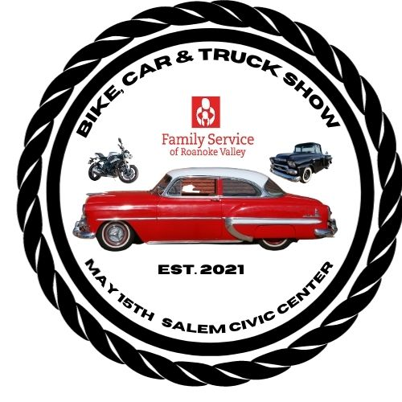
Mission Statement of Family Service of Roanoke Valley,
a 501(c)(3) charitable nonprofit organization:
“To transform lives by healing trauma and restoring hope for families and individuals of all ages through mental health counseling, case management and life skills education.
THANK YOU FOR SUPPORTING MENTAL HEALTH IN THE
ROANOKE VALLEY!

PARTICIPANT REGISTRATION FORM

Name:_____________________________________Phone Number: _________________________________

Street/Mailing Address: _____________________________________________________________________

City: _______________________________State_________________________Zip______________________

Car Club (please list only one please)___________________________________________________________

Email Address:_____________________________________________________________________________
(Note: We do not sell or rent any of our contact information).

Entrant’s Motorcycle/Car/Vehicle Information: Color:___________________________________________
Year: ______________________________Make________________________Model____________________

The Family Service of Roanoke Valley Bike, Car and Truck Show will take place on Saturday, May 15th in the Salem Civic Center parking lot from 10:00 AM – 4:00 PM. At this time, there is a rain date of Saturday, May 22nd. Should rain occur on the second date, the event is scheduled to take place rain or shine, unless inclement weather or a government mandate causes cancellation. Entry fees are non-returnable and will be considered a donation to Family Service of Roanoke Valley, a 501(c)3 charitable non-profit organization.

The gates open to registrants at 7:30 AM and entrant must be parked by 9:30 AM or parking space will be released. The show starts at 10:00 AM and ends at 4:00 PM with awards scheduled to take place at 3:00 PM. Entrants shall not remove their vehicle prior to the conclusion of the event without permission from an FSRV Bike, Car and Truck Show official.

I hereby assume full and complete responsibility for any personal injury to myself or others in my party, or for any loss or damage to my automobile(s), equipment, and personal property whether by accident, vandalism, acts of God, or any other issue which may occur during my participation in this event, and hereby indemnify, release, and hold harmless from any and all claims the nonprofit organization known as Family Service of Roanoke Valley, its directors, officers, staff members, volunteers, all event sponsors, and assigns. By signing, I agree that I have read and understand this document in its entirety.

Entrant Signature: _______________________________Date: ______________________________________

Please mail this completed form along with your payment to:
jsluss@fsrv.org
OR
FSRV
360 Campbell Avenue
Roanoke, VA 24016
Please make checks payable to Family Service of Roanoke Valley
REGISTRATION FEE: $25.00
SWAP MEET: $25.00 T-SHIRTS: $25.00 each
____I would like to order a t-shirt(s) in advance by indicating the quantity below:
Sizes:
____SMALL____MEDIUM____LARGE____XL____
____2XL____3XL____4XL____5XL___6XL___ ($5 EXTRA FOR THESE SIZES)
Total Payment Enclosed: ________________
Payment Method:

___I am enclosing a check

____Please charge my credit card:

Card Number: __________________________________________________________________
Expiration Date: _________________________Security Code Number: _______________
Billing Address: _______________________________________________
Join us for Prizes & Awards/Food Vendors/Music-to help those in the
Roanoke Valley dealing with a mental health challenge.
Please help us to promote this event by sharing our Facebook Event page and/or posts!
Facebook.com/FamilyServiceRVContact Information: Jill Sluss, Chief Development Officer, FSRV
(540)795-4671 or jsluss@fsrv.org

